Investigation 1:

Part 2: added new lines in dhcpd.conf file

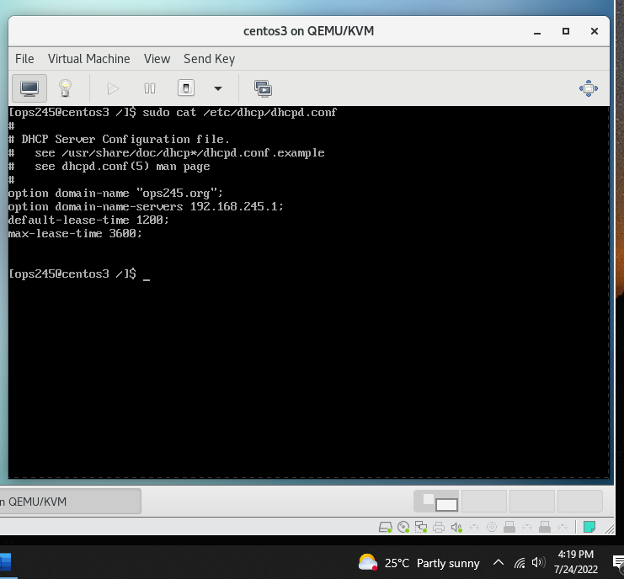

Part 3:

Ssh from c7host to centos3:  
  
Restart dhcpd after fixing the issue with the filesu

Wording dhcpd.conf file

Dhcp status

Part 4:

Rebooting centos1 and check /var/log/messages:

Centos1 ip address show:

Investigation 2:

Part2:

Fixed address received by centos1

